

Europass  Curriculum Vitae |  | 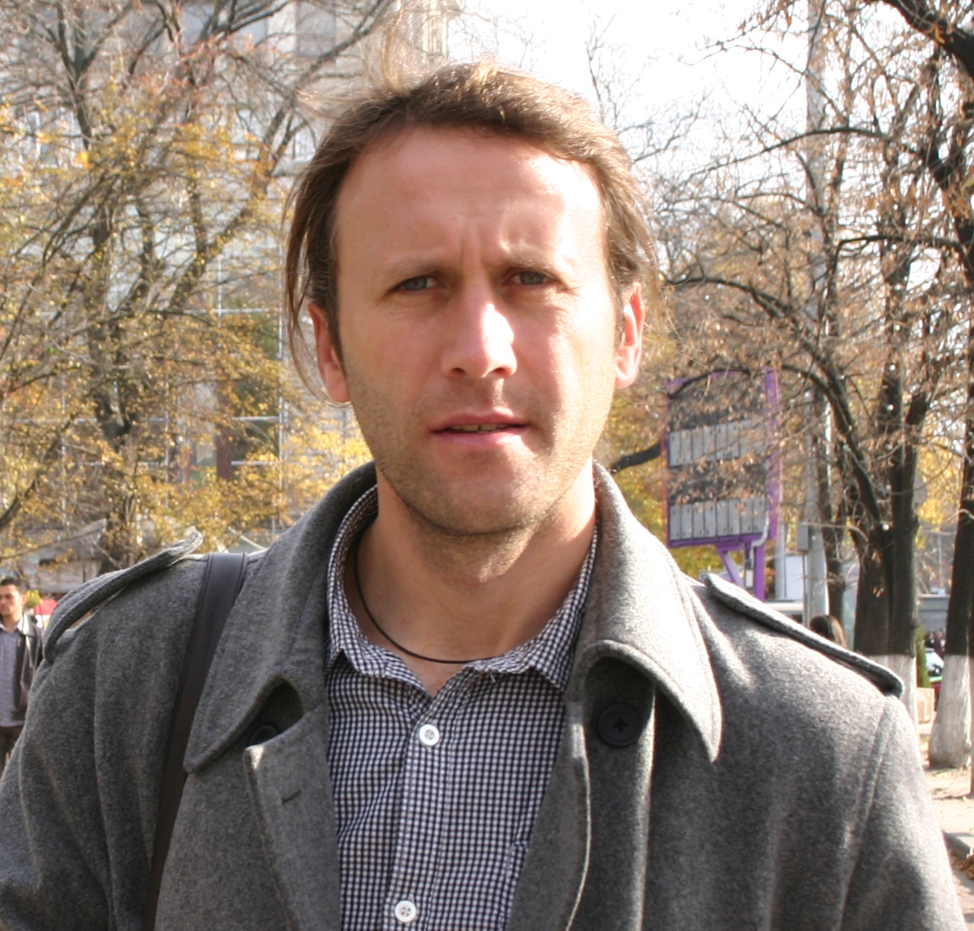
Personal information
First name(s) / Surname(s) |  | Marcel Mîndrescu
Address(es) |  | Eroilor, 8, Suceava
Telephone(s) |  | +40742051475
Fax(es)
E-mail |  | mmhans@atlas.usv.ro
Web page |  | http://atlas.usv.ro/www/geografie/mindrescu_marcel.php  www.mindrescu.net
Nationality |  | Romanian
Date of birth |  | 04.06.1974
Gender |  | male
Occupational field |  | Lecturer
Work experience
Dates |  | 1998 October to present day
Occupation or position held |  | Lecturer
Main activities and responsibilities |  | Teaching and research activities in Hydrology- Water Management, Limnology and Palaeolimnology, Glaciations and Mountain Environment
Name and address of employer |  | Stefan cel Mare University, Suceava
Type of business or sector |  | Education and researches
Education and training
Dates |  | 1993-2011
Title of qualification awarded |  | 1. University of Iasi, “Al. I. Cuza”, Geography Department (1993 – 1997), Bachelor Diploma P. no. 0079055  2. University of Iasi, “Al. I. Cuza”, Geography Department, Master Degree Studies – Dynamic geomorphology specialization; Certificate D. no. 0001149.  3. University of Durham, UK, Geography Department, Master Degree Studies in Glacial Geomorphology (March-June 1999). Erasmus student.  3. University of Iasi, “Al. I. Cuza”, Geography Department, PhD Diploma in Physical Geography, 2006. Thesis “The Geomorphometry of the glacial cirques in the Romanian Carpathians” awarded with Magna Cum Laude.  3. University of Durham (UK) – Doctoral studies and teaching: March – April 2003, April – May 2004, May – June 2005; Glaciation studies and teaching: May 2006, June 2006, January 2007, November 2007, November 2008, September 2009, September 2010. Erasmus stages.  4. University of Salford, Manchester (UK) – Paleolimnology trainings: June 2006, October 2007, October 2008, October 2009, October 2010. Erasmus stages.  5. University of Manchester(UK) – Glaciation studies training: October 2010. Erasmus stage.  6. Pedagogical University of Cracow (Poland) –Short glacial geomorphology trainings – December 2008, October 2009, September 2010; September 2011; Glacial geomorphology field trip in the Tatry Mts training – July 2009. Erasmus stages.  6. University of Bern, Institute of Geology (Switzerland) – Short tTraining: Paleoenvironment and caves, October 2011. Erasmus stage.
Principal subjects/occupational skills covered |  | Palaeolimnology, Climate Change in the Mountains, Glaciations, Mountain Geomorphology&Environment,
Name and type of organisation providing education and training |  | Al.I.Cuza University of Iasi, Faculty of Geography  Durham University, UK  Salford University, UK
Level in national or international classification |  | PhD
Personal skills and competences
Mother tongue(s) |  | Romanian
Other language(s)
Self-assessment |  |  | Understanding |  |  |  |  | Speaking |  |  |  |  | Writing
European level (*) |  |  | Listening |  | Reading |  |  | Spoken interaction |  | Spoken production
English |  |  | B1 |  | B2 |  |  | B2 |  | B2 |  |  | B1
French |  |  | A2 |  | A1 |  |  | A1 |  | A1 |  |  | A1
 |  | (*) Common European Framework of Reference for Languages
Social skills and competences |  | Team spirit, ability to cooperate with colleagues, adaptability to new working environment, honesty, leadership, organizer.
Organisational skills and competences |  | Ability to establish partnerships and motivate project colleagues  Experience of project management, as part of the implementation of research projects and other events (workshops, symposiums), as project manager and/or responsible for logistics, etc.
Technical skills and competences |  | Ability to adapt quickly to new fields of study  Proneness to interdisciplinary collaborations
Computer skills and competences |  | Advanced level of computer operation (Microsoft Office, Adobe Acrobat, Stata, etc.).  Advanced level of graphic applications (Corel Draw, Photoshop, MapMaker, Global Mapper, ArcGIS)
Driving licence |  | Yes
Additional information |  | - Erasmus coordinator for teaching and research training with 10 European universities (University of Durham, Manchester, Salford- UK; University von Humboldt Berlin-Germany; University of Bern, Institute of Geology- Switzerland; Pedagogical University of Krakow-Poland; University of West Bohemia of Pilsen, University of Ostrava- Czech Republic; University of Ljubljana- Slovenia; EÖTVÖS LORÁND TUDOMÁNYEGYETEM of Budapest-Hungary). One of the best grade in the Erasmus activity at University of Suceava.  - Strongly involved in the activities of Mountain Research Initiative Europe (MRI- http://mri.scnatweb.ch/mri-europe/carpathians/the-suceava-working-group ) and Past Global Changes (PAGES- http://www.pages-igbp.org/calendar/meetings-2011/1-pages-sponsored/18-balkan-carpathian ), core project of IGBP, funded by the U.S. and Swiss National Science Foundations and NOAA. As the result, the project leader received, from both associations, funds for organizing, as chairman, an international workshop to UNIVERSITY OF SUCEAVA with the topic 1st Workshop on Regional Climate Dynamics “CLIMATE CHANGE IN THE CARPATHIAN - BALKAN REGION DURING THE LATE PLEISTOCENE AND HOLOCENE” in June 2011 (http://atlas.usv.ro/www/climatechange/). Final report here, pag. 54: http://www.pages.unibe.ch/download/lucien/proofs.pdf  - Editor for the Special Volume of Peleoscience in Carpathian-Balkan area under Quaternary International Journal (under progress). Quaternary International is the official journal of the International Union for Quaternary Research (IF=1.768, Thomson Reuters Journal Citation Reports 2011).  - Group leader of the Working Group for Interdisciplinary Studies in the Carpathian-Balkan Area, under progress working group.  - Member of Past Global Changes (PAGES) established in Bern, Switzerland (http://4dweb.proclim.ch/4DCGI/all/en/Detail_Person?mindrescum.p57840)  - Author/co-author of 6 articles published in Web of Science, international journals of high impact factor.  - International Journals Reviewer: Central European Journal of Geosciences  http://versita.com/science/geosciences/cejg/; Quaternary Science Reviews  http://www.sciencedirect.com/science/journal/02773791; Lakes & Reservoirs: Research and Management, http://www3.interscience.wiley.com/journal/117979475/home; Quaternary International, http://www.journals.elsevier.com/quaternary-international/).  - Member in the Scientific Board of the International Conferences: Forum Carpaticum 2010 Conference (FC2010), Krakow, Poland; Forum Carpaticum 2012 Conference (FC2012) , Stará Lesná, Slovakia, 30 May – 2 June 2012 (www.forumcarpaticum.org).  - New Member of the S4C Scientific Steering Committee (SSC): http://mri.scnatweb.ch/sc4-news/new-members-of-the-s4c-scientific-steering-committee-ssc and http://mri.scnatweb.ch/mri-europe/carpathians/  - President of the Association of Applied Geography GEOCONCEPT (University of Suceava): http://atlas.usv.ro/geoconcept/index.php  - Scientific expeditions: Himalayas-Nepal (April 2011), Alps, North America etc.
Areas of competence  Publications |  | 1. Paleolimnology and limnology:  - limnology assessments on the lakes and beat bogs in the Carpathians  - short training periods in paleolimnology domain in the Salford University (supervisor: Dr. Simon Hutchinson); techniques of collecting cores, laboratory analyses, interpretation and dissemination of the results.  - promoting the results obtained in the Carpathians in the International conferences (see CV);  - studies regarding human impact on the lake basins (Lacul Stiol, Rodna; Iezerul Sadovei - Feredeu);  - a student course in digital format called paleolimnology (a new direction of teaching);  - international and national agreements in paleolimnology and palinology domains  - supervisor for student training periods in the pleolimnology in international laboratories;  - core sampling from lakes and peat bogs in the Romanian Carpathians and Tatry Mts;  - teaching items of the grant manager to University of Suceava (bachelor and master): Hydrology, Water Management, Limnology/Paleolimnology, Risk and Hazard in Hydrology, GIS and application in hydrology.  2. Glaciation:  - inventory of the all cirques and glacial lakes in the Romanian Carpathians  - data base regarding erosion glacial features in the Carpathians (including maps),  - promoting the Romanian glaciology to the International conferences (see CV)  - training periods and stage studies in glacial geomorphology (University of Durham – supervisor Ian Evans; Pedagogical University of Krakow);  -carry out of studies published with international journals  - scientific expeditions in Himalayas, Alps, High Scotland, Lake District  3. Carpathian Environment  - good connoisseur of the Carpathian mountains environment and especially of all the glaciated sites;  - coordinator of summer camps in the area of Romanian Carpathians;  - member of Carpathian European Forum; Past Global Changes and Mountain Research Initiative  - promote the Carpathian environment in professional conferences and lectures abroad.  1. Knorn J., Kuemmerle, T., Radeloff, V.C., Szabo, A., Mîndrescu, M., Keeton W.S., Abrudan I., Griffiths P., Gancz V., Hostert P., 2012. Forest restitution and protected area effectiveness in post-socialist Romania. Biological Conservation, Volume 146, Issue 1, February 2012, Pages 204-212. doi: 10.1016/j.biocon.2011.12.020.  (online: http://www.sciencedirect.com/science/article/pii/S0006320711004836)  2. Akinyemi, F.O., Hutchinson, S.M., Mîndrescu, M., Rothwell, J.J., 2012. Lake sediment records of atmospheric pollution in the Romanian Carpathians. Quaternary International: Manuscript accepted: DOI: 10.1016/j.quaint.2012.01.022  (online: http://www.sciencedirect.com.ezphost.dur.ac.uk/science/article/pii/S1040618212000377)  3. Mindrescu, M., Cristea A.I., Hutchinson, S.M., Feurdean, A., Florescu, G., 2012. Iezer-Feredeu and Bolătău-Feredeu Lakes; the oldest landslide dammed lakes in Romania. Quaternary International, in press.  4. Fărcaş, S., Tanţău I., Mîndrescu M., Hurdu B., 2012. Holocene vegetation history in the Maramureş Mountains (Northern Romanian Carpathians). Quaternary International. doi: 10.1016/j.quaint.2012.03.057.  5. Mindrescu M., Evans I.S., Cox N.J. (2010), Climatic implications of cirque distribution in the Romanian Carpathians: Palaeowind directions during glacial periods, Journal of Quaternary Science (2010) 25(6) 875–888).  6. Mindrescu, M., Cristea, I.A., Hutchisnon, S.M. (2010), Bathimetrical and sedimentological changes of glacial lake Stiol, Rodna Masiff, Carpathian Journal of Earth and Environmental Sciences,Vol. 5, No. 1, p. 57 – 65).
Conferences  Conferences |  | 7. Mindrescu M., Iosep I., Cristea I.A., Forgaci D., Popescu D.A. (2010), Lacurile Iezer si Bolatau (Obcina Feredeului)- cele mai vechi lacuri de baraj natural formate prin alunecare din Romania, Volumul Simpozionului National Resursele de apa. Vulnerabilitate la presiunea activitatilor antropice cu referire si la ecosistemele lacustre, 272-282, Targoviste, 11-13 iunie 2010.  8. Mindrescu M., Cristea I.A., Florescu G. (2010), Water quality and ecology of the Iezer and Bolătău lakes, Lakes reservoirs and ponds Romanian Journal of Limnology, 4 (1-2), 117-130, 2010.  9. Fărcaş, Sorina, Tanţău, I., Mîndrescu, M., Hurdu, B., Filipaş, L., Ursu, T. (2009), Pollen analysis of the sequence from the peat bog Tăul Mare - Bardău (Maramureş, Romania), în: A. Curtean-Bănăduc, D. Bănăduc & I. Sîrbu (eds.), „The Maramureş Mountains Nature Park”, Trans. Rev. of Syst. and Ecol. Res., Sibiu, 5, 2009, p. 21-30.  10. Fărcaş, Sorina, Tantau I., Hurdu B., Mîndrescu M., Filipas L. (2009), Phytohistorical aspects of the Natura 2000 site “Maramures Mountains”, Contrib. Bot., Cluj-Napoca, XLIV, 2009, p. 131-140.  11. Mindrescu M. (2009), Glacial asymmetry in The Făgăraş Massif, Analele Universităţii „Ştefan cel Mare” Suceava, Secţiunea geografie, anul XVIII-2009, p. 25-34.  12. MÎindrescu M. (2008) - A new glacial area in Rodna mountains – Tarniţa din Ciung cirque, Analele Universităţii „Ştefan cel Mare” Suceava Secţiunea Geografie, XVII,p. 79-86, 2008.  13. Mindrescu, M, 2004a. Topographic and climate conditions required for glacier formation in cirques, Annals of the University of Kharkov, 620, Kharkov, Ukraine.  14. Mindrescu, M, 2004b. Lala Lake (Rodna Mt). Biochemic Study. Seminarul geografic “Dimitrie Cantemir” Iasi, 25, 149-158 (in Romanian).  15. Mindrescu, M, 2003a. The Livia Lake (Northern Maramureş Range). Hydrological and morphological aspects. Annals of the University of Suceava, Geography section, XII, 49-55 (in Romanian).  http://atlas.usv.ro/www/anale/datagrid/uploads/documente/06.Anale2003_%20Mindrescu.pdf  16. Mindrescu, M, 2003b. Analysis and clasification of the Maramures Mountains based on their geomorphometry, Annals of the University of Timişoara, geography section, XIII.  http://www.geografie.uvt.ro/cercetare/publicatii/anale/anale2003.htm  17. Mindrescu, M, 2002. The Jupania Massif ( Southern Maramures Range). A new glaciated area in the Eastern Carpathians, Annals of the University of Suceava, geography section, XI, 41-47 (in Romanian).  http://atlas.usv.ro/www/anale/datagrid/uploads/documente/06.Anale2002_Mindrescu.pdf  18. Mindrescu, M, 2001a. The Lala armchair cirque (Rodna masiff). Annals of the University of Suceava, geography section, X (in Romanian). http://atlas.usv.ro/www/anale/index.php#  19. Mindrescu, M, 2001b. Vinderel Lake (Maramureş Mts). Morphohydrological aspects. Annals of the University of Suceava, Geography section, X (in Romanian).  20. Mindrescu, M, 2001c. The geomorphometry of mountains. Revista de geomorfologie, III, Bucureşti (in Romanian).  21. Mîndrescu, M., 1997. Perenitatea formelor de relief glaciare din Munţii Maramureşului. Annals of the University of Suceava, geography-geology section, VI, 45-48 (in Romanian).  - Mindrescu M., Cristea A.I. (2011), Rock mass failures and antislope scarps in the Northern Romanian Carpathians, Carpatho-Balkan-Dinaric Conference on Geomorphology, Ostravice, Czech Republic, 17-20 Oct. 2011.  - Cristea Al. I., Mindrescu M. (2011), River channel sensitivity in the Carpathian Curvature in the light of cartographic materials. Case study: Putna River, Carpatho-Balkan-Dinaric Conference on Geomorphology, Ostravice, Czech Republic, 17-20 Oct. 2011.  3. Hutchinson Simon M., Akinyemi Olusola, Mindrescu Marcel , Rothwell James J. (2011), An overview of the recent palaeolimnology of selected lakes in the Romanian Carpathians, 1st Workshop on Regional Climate Dynamics “Climate Change in the Carpathian-Balkan Region During the Late Pleistocene and Holocene”, University of Suceava, Romania, June 9-12, 2011.  4. Cristea, A.I., Mîndrescu, M., Evans, I.S. (2011), Channel planform changes of Putna River in the last 100 years, Congress of Geomorphometry, Redlands, California, USA, 7-9 Sept 2011. http://geomorphometry.org/content/geomorphometry-2011-programme  5. Mîndrescu, M. (2010), Flood risk in small basins in the northern Romanian Carpathians, International Conference Water: History, Resources and Perspectives, Chişinău, Rep. of Moldova, 5-6 Nov 2010.
6. Hutchinson, S.M., Blackford J.J., Mindrescu M., Rothwell J.J., 2009 – The recent palaeolimnology of crater lake Sfanta Ana in the Romanian Carpathians, 11th International Paleolimnology Symposium, Guadalajara, Mexico, 15th December 2009.
http://www.geofisica.unam.mx/paleolimnologia/files/programa_def.pdf
7. Hutchinson S.M., Akinyemi O., Mindrescu M., Rothwell J.J., 2009 – Assessing the impacts of atmospheric particulate pollution on mountain lakes in the Romanian Carpathians, 11th International Paleolimnology Symposium, Guadalajara, Mexico, 15th December 2009.
8. Mîndrescu M. (2009), Some aspects of impact of pollution caused by Uranium prospect mining in the Northern Maramureş Mountains, Simpozionul Internaţional de Geografia Mediului “Mediual actual şi Dezvolatrea durabilă”, Ediţia IV, 16-18 October 2008, Iaşi, România.
9. Mîndrescu M. (2009), Topographic and Climate Conditions Required for Cirque Formation, British Society for Geomorphology INTERNATIONAL ANNUAL MEETING 2009. Durham University, UK, 4-9 September 2009. www.geography.dur.ac.uk/conf/bsg09/
10. Mîndrescu M., Cristea A.I. (2009) - A model of the glacial cirques geomorphometry in the Romanian Carpathians, British Society for Geomorphology ANNUAL MEETING 2009. Durham University, UK, 4-9 September 2009.
11. Farcas S., Tantau I., Hurdui B., Mîndrescu M., Filipas L. (2009), Phytohistorical aspects of the “Natura 2000” site “Munţii Maramureşului” (Romanian Carpathians), International Symposium BIODIVERSITY: PERPETUATION OR CONSERVATION?, Babeş-Bolyai University, Faculty of Biology and Geology, Department of Taxonomy and Ecology, iunie 2009
12. Mîndrescu M. (2009), Ştiol – a disabled lake, Simpozionul Internaţional Calitatea Mediului şi Utilizarea Terenurilor, ed. VII, Suceava, mai 2009.
13. Mindrescu M., I.S. Evans (2009), Climatic implications of cirque distribution in the Romanian Carpathians: Palaeowind directions during glacial periods, The 13th ALPINE GLACIOLOGY MEETING, Innsbruck, Austria, April 2009.
http://imgi.uibk.ac.at/IceClim/IceClim/AGM_2009/agm_home.html
14. Mindrescu M. (2008), Regional Disparities Regarding Glaciation in the Romanian Carpathians, International Conference „Regional disparities: Typology, Impact, Management”, 25th-26th October 2008, Cluj- Napoca, Romania.
15. Mindrescu M. (2008), Un exemplu de impact antropic asupra unui mediu lacustru: lacul glaciar Ştiol, Masivul Rodna, Simpozionul Internaţional de Geografia Mediului “Mediual actual şi Dezvolatrea durabilă”, Ediţia III, 17-19 octombrie 2008, Iaşi, România.
16. Evans I., Mindrescu M. (2008), The allometric of glacial cirques, Lucrările Seminarului Geografic Internaţional „Dimitirie Cantemir”, Ediţia XXVIII-a, 17-19 October 2008, Iaşi, România
17. Hutchinson S.M., Akinyemi, O., Mindrescu M., Rothwell J.J. (2008), Assessing the potential of lake sediment records of environmental change in the Romanian Carpathians. Preliminary data from the Rodna and Maramureş Mountains, IAG Regional Conference on Geomorphology, Landslides, floods and Environemental Change in the Montain Regions, Spetember 2008, Braşov.
18. Mindrescu M., Hutchinson S.M. (2008), Environmental Magnetic Susceptibility of Glacial Lake Sediments in the Northern Romanian Carpathians, 31st International Geographical Congress, 12-15 August, Tunis, Vol. 31, IGC 2008, p.269-270.
19. Mindrescu M., Cristea Al. I. (2008) – Allometry of the glacial cirques in the Romanian Carpathians, International Symposium of the Technical Geography, June 2008, Cluj Napoca, Romania.
20. Mindrescu M. (2008), Glacial cirque development and distribution in the Romanian Carpathians, European Geosciences Union Assembly, Vienna. Vol. 10, EGU2008-A-03118, 2008 (ISSN 1029-7006).
21. Mindrescu M. (2006), Geomorphology of glacial cirques in the Romanian Carpathians, BGRG International Conference, 28-30 iunie 2006, Loughborough University, UK. http://www.lboro.ac.uk/ departments/gy/gess
22. Mindrescu M., Evans, I. (2007), Glacial cirques development and distribution in the Romanian Carpathians, Carpatho-Balkan-Dinaric Conference on Geomorphology, under IAG auspices, 24th-28th 2007, University of Pecs, Hungary.
23. Mindrescu M., Hutchinson S.M. (2007), Palaeolimnology studies in the Northern Carpathians, International Conference of Geography of Environment, Mediu Actual şi Dezvoltare Durabilă, Iaşi, Romania.
24. Cristea, I.A., Rădoane, M., Mîndrescu, M. (2012), Putna River's channel (South - Eastern Carpathians) reflected by cartographic materials. EGU General Assembly 2012, Vienna, Austria, 22-27 April 2012, (abstract submitted to GM7.1 and accepted).

25. Mindrescu, M., Hutchinson, S., Feurdean, A., Brancelj, A., Cristea, I.A., 2012. Interdisciplinary investigations of the laminated sediments in the Iezer-Feredeu and Bolătău-Feredeu lakes, Romania. Forum Carpaticum, 30 May/2 June 2012, Stara Lesna, Slovakia.
http://uke.sav.sk/fc/fc_2012/FC_2012_Presentations_and_posters.html#12

Marcel MINDRESCU



April 2012

